All Git Commands (might come handy):
1-Add new remote repo to local repo via terminal:
git remote add Js https://github.com/ImRaNM-001/Basic_JS_programs_19-Dec-2019 (Js is just a remote name)

2-Set remote URL:
git remote set-url Js https://github.com/ImRaNM-001/Basic_JS_programs_19-Dec-2019

3-See existing remotes with their names & url’s:
git remote -v
JS https://github.com/ImRaNM-001/Basic_JS_programs_19-Dec-2019 (fetch)
JS https://github.com/ImRaNM-001/Basic_JS_programs_19-Dec-2019 (push)

4-Enter into GitHub repository (which will display pop up window) to enter GitHub URL & Password:
[git “fetch” command downloads commits, files, and refs from a remote repository into your local repo]
git fetch Js (again Js is remote name)

5-Check status of repository:
git status
- On branch master
No commits yet
nothing to commit (create/copy files and use "git add" to track)

6-Download all files from GitHub repository to local repository (run it after GitHub repository is sync’d to local one):
git pull Js (again Js is remote name)

7-Add files to GitHub repository from local repository:
For Single File | For All Files
--yet to update-- | --yet to update--

8-Remove files from local repository to GitHub repository:
For Single File | For All Files (it will remove all files from folder location at one shot)
git rm const_vs_let_Keyword.js  (git rm filename.js) | git rm -r C:\testAutomationPractice\repooo  (git rm – r folderpath)

9-Commit changes post removal from local repository:
[git "commit" command is used to save your changes to the local repository]
For Single File | For All Files
git commit -m remove const_vs_let_Keyword.js  (git commit -m remove filename.js) | git commit -m C:\testAutomationPractice\repooo  (git commit –m folderpath)

10-Push changes from local repository to GitHub repository master branch:
[git "push" command is used to upload local repository content to a remote repository]
git push Js master (syntax: git push repo_name branch_name where Js is remote name and master is branch name)
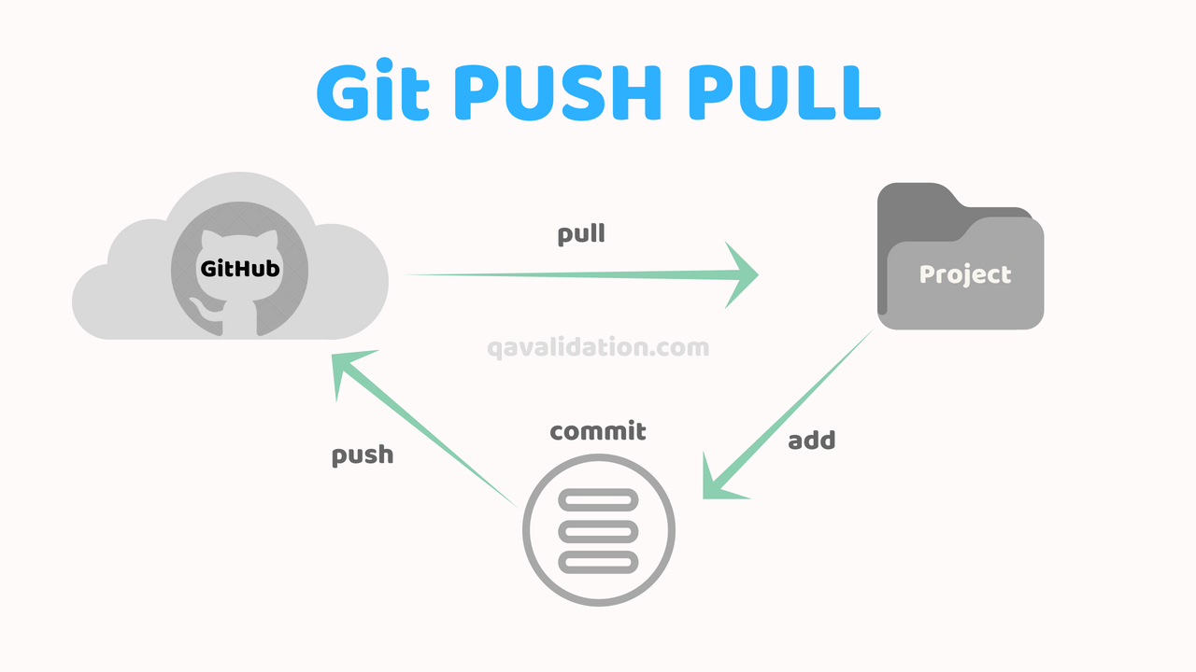
11-If prompted to authenticate yourself ie, if below statements are coming in terminal,
“please tell me who you are” error:
(for email): git config --global user.name ImRaNM-001
(for name): git config --global user.email imu163@gmail.com
(ignore --global if needed to set the identity only in 1 local repository)
12-Check Logs which show commit ids, author and date:
git log

1x- (Exclusive GitBash Commands):
clear screen: clear
exit screen: exit

***Bastard command never even touch it:
git reset --hard origin/master (ex: git reset --hard JS/master)
[Note: instead of doing a git pull, you can do:
git fetch
git reset --hard origin/master
Neither of those require you to configure your git user name / email.
This will destroy any uncommitted local changes / commits, and will leave your HEAD pointing to a commit (not a branch). But neither of those should be a problem for an app server since you shouldn't be making local changes or committing to that repository]

